MGCC 3 Man Tournament
April 11-12, 2026

$300.00 per team (106.00 per player, tax included)
$$ CASH PAYOUTS in each Flight
SCRAMBLE FORMAT 18 HOLES
SKINS GAME
MULLIGANS
SHOTGUN START BOTH DAYS AT 12:00 PM
SENIOR TEES 60+

ENTRY FEE INCLUDES: 1 PRACTICE ROUND (cart not included), SATURDAY NIGHT MEAL

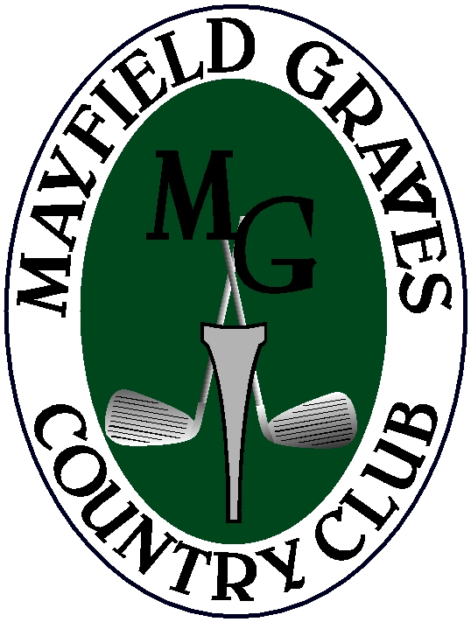
PLAYER 1 NAME:

PLAYER 1 PHONE:
Flights and Payouts will be determinded by number of entries

Flights will be made after Saturday’s round. Ten percent rule will be in effect.

PLAYER 2 NAME:

PLAYER 2 PHONE:

PLAYER 3 NAME:

PLAYER 3 PHONE:

NO ENTRIES WILL BE ACCEPTED WITHOUT PAYMENT, FIELD LIMITED TO FIRST 36 PAID TEAMS. You are encouraged to bring your own cart, limited rental carts are available for an additional $40.00 (plus tax, $42.40) per day. This must accompany your tournament entry fee.

Member Charge:
Credit Card:________________
Check:_____________________
Cash:______________________
Please make all checks payable to: MGCC

Call the Pro-Shop today to sign up 270-247-1862

